New Hydrophilic Insulation: 3-APTMS (3-aminopropyltrimethoxysilane).
The CNNS is now offering MEAs with aminated surfaces that allow direct decoration with poly-D-lysine, eliminating the need for surface activation.

Thickness: 2 um
Shunt Impedance: 6-8 megohms
Electrode Impedance 0.6 - 0.8 megohms
*maximum explored time range
Chemical tolerance: stable under 3% bleach; 70% ethanol for 3 days*
Heat tolerance: 165 deg C (2 hrs for heat sterilization)
UV tolerance: germicidal UV (2 hrs*)
Sterilization: heat, UV, or chemical, autoclaving is not recommended.
Stability under culture conditions: 8-10 cycles of sterilization and cell culture
(1 to 2 months under medium per cycle).
Strength of adhesion: Networks have tolerated 150 - 200g lateral impact forces without loss of cell- electrode coupling (n= 18 networks).

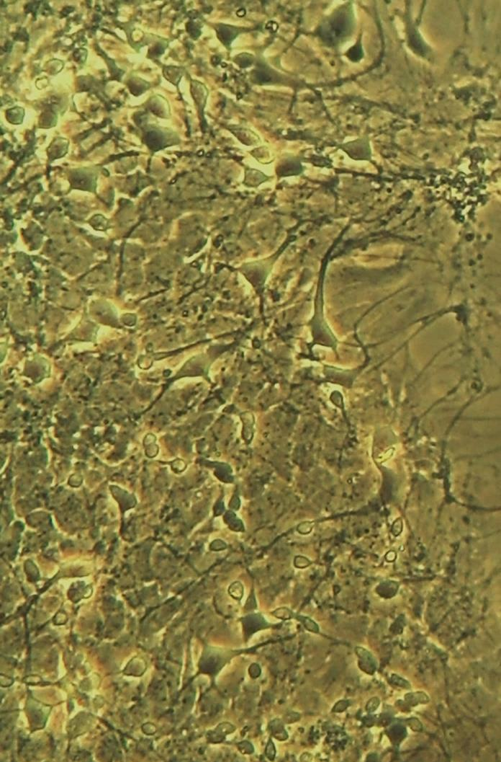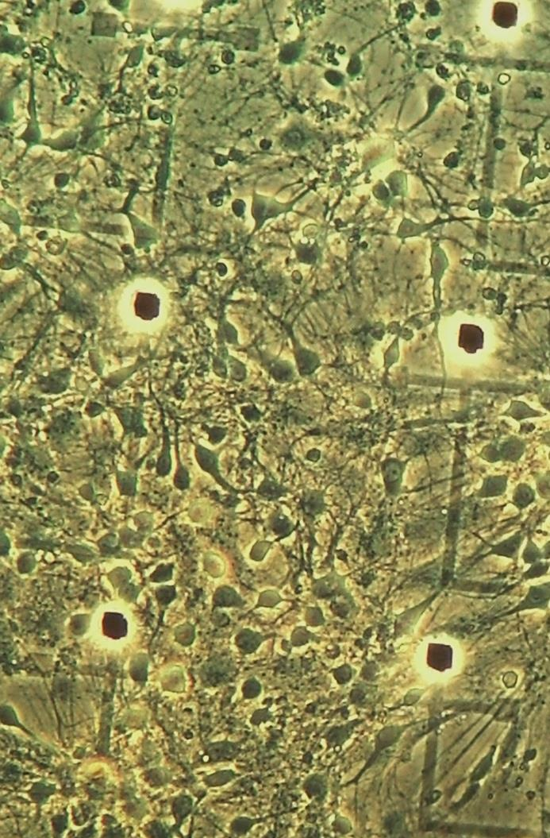
Culture development 9 days after seeding. 3-aptms insulation and PDL (no laminin)

